LAKE SHORES CIVIC LEAGUE GENERAL MEETING MINUTES
Date of Meeting: November 18, 2025, 7:00 p.m. in the cafeteria of Shelton Park Elementary School.
Twenty-six neighbors signed in. Date of our next General Meeting is on January 20, 2026 on the third Tuesday of the month unless a conflict with Shelton Park Elementary School (SPES).

Our Purpose
The purpose of this organization shall be to bring together for mutual benefit, those persons who are interested in civic betterment of any kind. It shall be operated along democratic lines, having no political affiliation, and being non-sectarian in the matter of religion

Call to Order, Pledge of Allegiance, & Welcome
President Diane called to order, welcomed all, & invited us to join in the Pledge of Allegiance.

Guest Speakers
Our guest speakers from Dominion Energy: Max Bartholomew, Jacob Carasella, Devin Hedrick, Cherise Newsome, Brandon Thomas

An electronic copy of the handout from our speakers, Burton – VA Beach (Line 27) 115 kV Electric Transmission Line Rebuild Project Update, is posted on our Website: Lakeshores.org.

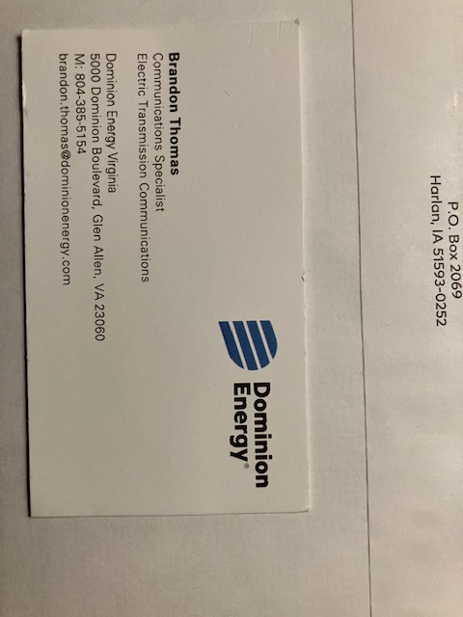

Generating sources are nuclear power plant, solar, wind farms.
Poles are transmission & distribution.
The new poles are of steel replacing poles 50 years old.
Lake Shores is in Phase One of the project.
Now in the rehab phase – planting grass, replacing fencing, trees, & grass
Should be complete by April 2026.
Phase Four: September 2006, most difficult as the last storm took the structures.
All poles replaced by December 2027.
We await rehab in Lake Shores.
An environmental concern is the osprey nests.
The new poles deter birds so stands are not needed.
The environmental team – biological survey – important new structures are safe for birds
Birds can nest elsewhere.

Dominion Energy rate change is the first since 1992.
The SCC must approve, deny, or give a different amount.
We are waiting for the SCC decision.
Dominion Energy is a corporation.
All information is on the SCC Website: https://www.scc.virginia.gov/
If approved, a $22.00 increase per month due to inflation, labor, equipment, fuel.
Lines are not underground as underground requires the same amount of land, digging takes longer,
coil for conductor every 4000 feet, impactful.
The new structures will last for 50 plus years.
Legally structures must be higher on the east coast – mitigations & expensive for Dominion Energy
if structures are down.

Secretary Report
Secretary Jeanne Marie read portions of the minutes from our last meeting held on May 20, 2025.
Our meeting in September was cancelled due to heavy rainfall and flooding.
Diane moved to accept the minutes.
As no additions or corrections, the minutes were approved.
Jeanne Marie reported no new communications.

Treasury Report
Treasurer Dodie read the Treasurer’s Report.
Account balance on 05/20/25 was $2067.50.
$56.00 in donations were made at National Night Out to put towards our new signs!
$10.00 in dues were collected at NNO.
NNO expenses were paid courtesy of Viking Enterprises and the Coreys, so a big that you to them!
We paid $50.00 in dues to the Virginia Beach Council of Civic Organizations in June.
Current total balance is $2103.50 of which $380.00 is for our new signs.
$2133.50
- 380.00 – sign fund
$1723.50 – remaining balance
Please remember we are in a new fiscal year, so please pay your dues at your earliest convenience.
Diane moved to accept the report.
As no additions or corrections, the report was approved.

COMMITTEE REPORTS

Virginia Beach Council of Civic Organizations (VBCCO)
Second VP Dave and VBCCO Rep:
VBCCO meets monthly on Wednesday nights as a liaison to City Council.
Residents of Lake Shores can go to VBCCO then to City Council.
VBCCO is a central organization to work with City Council.
Neighborhoods together

Citizen Advisory Committees (CAC) – Third Precinct
Dodie presented the report for Trustee and CAC Rep Rick:
Speaker at the CAC meeting was Deanna Parish, Virginia Beach Public Engagement Coordinator.
The most important message: Don’t leave your car running when you’re “just going to run in” to pick up food, etc. Criminals are watching and waiting to steal your car. Frequent targets are food delivery such as door dash, etc. Sometimes kids are still in the car.

City Website: VirginiaBeach.gov
- SpeakUpVB.com: surveys set up periodically by the City (recent one was recycle preference)
- Serve on a City appointive agency – She advises the City Council on a wide range of specific topics.
- Easily contact your district councilman or the entire City Council
Speak at City Council meetings
Attend Town Halls given by City Council members
“Be in the Know”: virginiabeach.gov/beintheknow
- Biweekly email newsletter gives info on surveys, VB news, etc.
- Over a dozen mobile apps – here are a few:
- Ready VB: Resources and information to prepare for emergencies before they happen
- Smart911: Residents with household members with disabilities or mental health challenges can provide vital info in advance for emergency responders
- VB Alert: Text notifications of public safety incidents, such as weather alerts specific to your area
- VB Connect: Your specific property info such as recycle days, your plat, specifics
- Eleven other apps within VB Connect:
VB Works: Report any problem such as pothole, streetlight outage,
graffiti, flooding, etc.
VB Park Finder
VB Go: Events in VB, such as Sandler Center, Parks & Rec, etc.
VB Public Library Catalog: Thousands of e-books and audiobooks you
can borrow instantly, for free
CAC Crime Report:
Third Precinct Report: Captain Gordon
All categories of crime are down 31 percent month to month and year to year except car thefts – see “The most important message” above.
The next meeting: November 20.

Adopt a Street
Coordinator Jack:
We will meet on November 22 at 9:00 a.m. at the Pump House on Jack Frost Road.
Wear long sleeves & gloves.
Jack has grabbers, bags, safety vests
In case of rain, Jack will be at the pump house to let volunteers know to return home.

OLD BUSINESS

Dodie: Our neighborhood signs are now 12 to 14 years old, the plywood is coming apart.
Rick and Dodie take down the signs before storms and high winds.

NEW BUSINESS

A neighbor is interested in the zoning sign at Lake Shores Shopping Center.
An event venue plans to move in.

Diane: Our meeting in September was cancelled due to inclement weather.
Should we meet the week following the cancelled meeting or wait for two months for the scheduled meeting?
A speaker may not be available if we meet a week later.
First VP Craig schedules our meetings with the principal of Shelton Park Elementary School.
Diane will talk with the principal.

A neighbor informed us of the nine-year-old girl who was attacked by dogs in Lake Shores.

A neighbor gave details re: the eleven-year-old boy who was attacked on the path between Lake Shores and the shopping center.

Water Pressure in Lake Shores
Dave contacted the City.
A static pressure test was performed: 42 pounds
With the tap open dynamic pressure was lower.
Dave advises soaking shower heads in vinegar.

ADJOURNMENT

Diane:
Our next meeting is on January 20, 2026.
Diane asked for questions, invited us to suggest speakers for future meetings, then moved that the meeting be adjourned.
The motion to adjourn was seconded.
All agreed & the meeting was adjourned at 8:00 p.m.

Respectfully Submitted,
Jeanne Marie Macdonald, Secretary

