**LAKE SHORES CIVIC LEAGUE GENERAL MEETING MINUTES**

Date of Meeting: November 19, 2024, 7:00 p.m. in the cafeteria of Shelton Park Elementary School.

Nineteen neighbors signed in. Date of our next General Meeting is November 19, 2024.

**Our Purpose**

The purpose of this organization shall be to bring together for mutual benefit, those persons who are interested in civic betterment of any kind. It shall be operated along democratic lines, having no political affiliation, and being non-sectarian in the matter of religion

**Call to Order, Pledge of Allegiance, & Welcome**

Second VP Craig called to order & welcomed all.

Diane invited us to join in the Pledge of Allegiance then introduced our guest speakers.

**Guest Speakers – Animal Control Officers Buckner & Price, Virginia Beach Police Department**

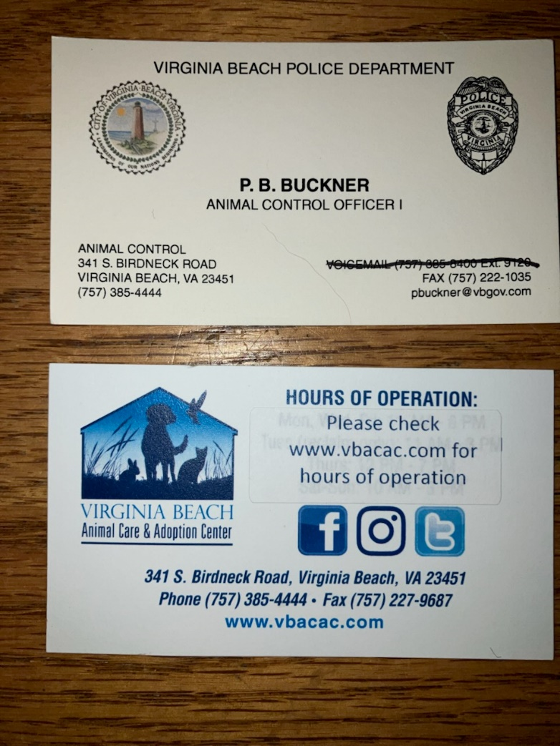

Our guest speakers placed handouts on the table for all to keep.

Virginia Beach Animal Care & Adoption Center on Birdneck Road offers adoptions & reclaiming.

Lost animals are posted on the website, best to go in person.

Advise to keep microchip current, especially military.

Animal Control can scan dogs & cats.

Virginia Beach has no limit on the number of cats in home.

Four dogs are allowed.

If feeding feral cats, they are yours.

City license, rabies, & kennel license required.

Cats cannot roam in neighbors’ yards – cat at large.

Fee is $50.00 in the shelter & going up.

Virginia Beach has no trap/release.

Cats decimate the local bird population.

Motion sensors which shoot water are available.

Pets with ID: ten-day hold.

Pets without ID: five-day hold.

Virginia Beach Animal Control works with the SPCA.

Officers will post a notice on the door re: barking dogs.

In reporting excessive barking, video is your friend.

Fox & bunny population is in cycles.

If assisting a turtle in the road, move the turtle in the direction headed or from sunny spot to sunny spot.

Box turtles cannot survive in the water & are territorial & fight.

Rabies is airborne.

This year has a big distemper outbreak among raccoons.

Raccoons get same distemper as pets.

Distemper is similar to rabies, a neurological disorder.

Vision is a blurry blob, no longer afraid, the mind is gone, lethal for raccoons.

As the population of raccoons increases, spread of the disease, every four or five years, started at the Oceanfront, is slowing down.

Nutria dig in banks along shoreline, take down trees, very destructive.

Place rocks on banks to prevent.

Possums are our friend, not destructive, eat carrion.

More cases of rabies among horses than possums.

Rabies is treatable in pets; wildlife are wild, untreatable.

After showing symptoms, too late.

Never pick up a rabid animal.

By law, we must report a scratch or bite from a dog.

Found dogs through VB Adopt are kept in homes as foster to keep them out of the shelter.

**Secretary Report**

Minutes: Secretary Jeanne Marie read portions of the minutes from our last meeting held on

September 24, 2024.

Craig moved to accept the minutes.

As no additions or corrections, the minutes were approved. .

Communications: Jeanne Marie reported no new communications.

**Treasurer Report**

Treasurer Dodie read the Treasurer’s Report.

Account balance on 09/24/24 was $1864.50.

No donations were made to put towards our new signs.

$40.00 in dues were collected at the September meeting.

No expenses were incurred in September or October.

Current balance is $1904.50 of which $311.00 is for our new signs.

$1904.50

- 311.00 sign fund

$1593.50 – remaining balance

Craig moved to accept the report.

As no additions or corrections, the report was approved.

**COMMITTEE REPORTS**

**Virginia Beach Council of Civic Organizations (VBCCO)**

Second VP Dave could not attend the VBCCO Meeting.

Dave will attend the meeting on November 20, 2024 & will attend the next Citizens Advisory Committees (CAC) meeting.

**Citizen Advisory Committees (CAC) – Third Precinct**

Trustee Rick attended the meeting at Williams Farm on the third Thursday of the month & met police officers, captains, & representatives from the recreation center.

Police use a drone system, operated by police helicopter pilots & Black Hornet drones.

Drones are faster than police cars.

**Neighborhood Watch**

NHW is quiet, nothing reported for last two months.

Incident reports in Lake Smith condos & the trailer court.

Hit & run, robberies are reported.

Reports on Northampton Boulevard. & Shore Drive.

Violent crime is down, increase in violent gun use.

We are advised to report suspicious activity.

911 will not turn down a report.

Always lock your vehicle.

Be a responsible gun owner, take guns indoors.

Females should utilize the buddy system.

Keep packages out of sight.

**OLD BUSINESS**

No old business reported.

**Adopt a Street**

Coordinator Jack: We meet on Saturday, November 23, at 9:00 a.m. at the Pump House

on Jack Frost Road.

Wear long sleeves & gloves.

Jack has grabbers, bags, safety vests

A neighbor asked if we could clean the pathway at the end of Meredith Road connecting to the Lake

Shores Shopping Center.

**ADJOURNMENT**

Our next meeting is on January 21, 2025.

We meet in November, January, March, & May.

In March & May, nominations for officers: President, Vice President, Second Vice President, Secretary, Treasurer, Trustees

Craig asked for questions then moved that the meeting be adjourned.

The motion was seconded.

All agreed & the meeting was adjourned at 7:59 p.m.

Respectfully Submitted,

*Jeanne Marie Macdonald*, Secretary